Performance Report

JMeter



Tomás Conceição

Tests on Development Server

Test Details

The test was fairly simple: JMeter would send, for each thread, a login request to the server. This will be enough to see how many requests the server can handle and also test our database, as each request will also make a database query for fetching the user and authenticate him.

10 Users, 10 Ramp-Up Time

With 10 Threads (Users) and a Ramp-up time of 10 seconds, the server behaved normally. The average request time was 34ms and all requests where successful. This means that the server can handle a request for second, which is expected.

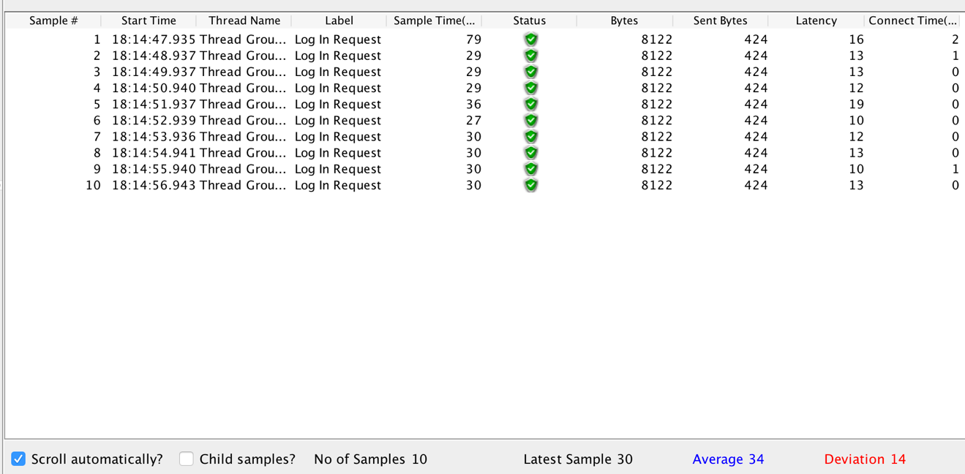

100 users, 10 Ramp-Up Time

With 100 users and 10 Ramp-Up Time, the server also behaved normally. All requests where successful and the average time for each request was 50ms. Even though the average time for the requests was bigger, it was still a decent time. This means that the development server can handle 10 requests per second, for 10 seconds.

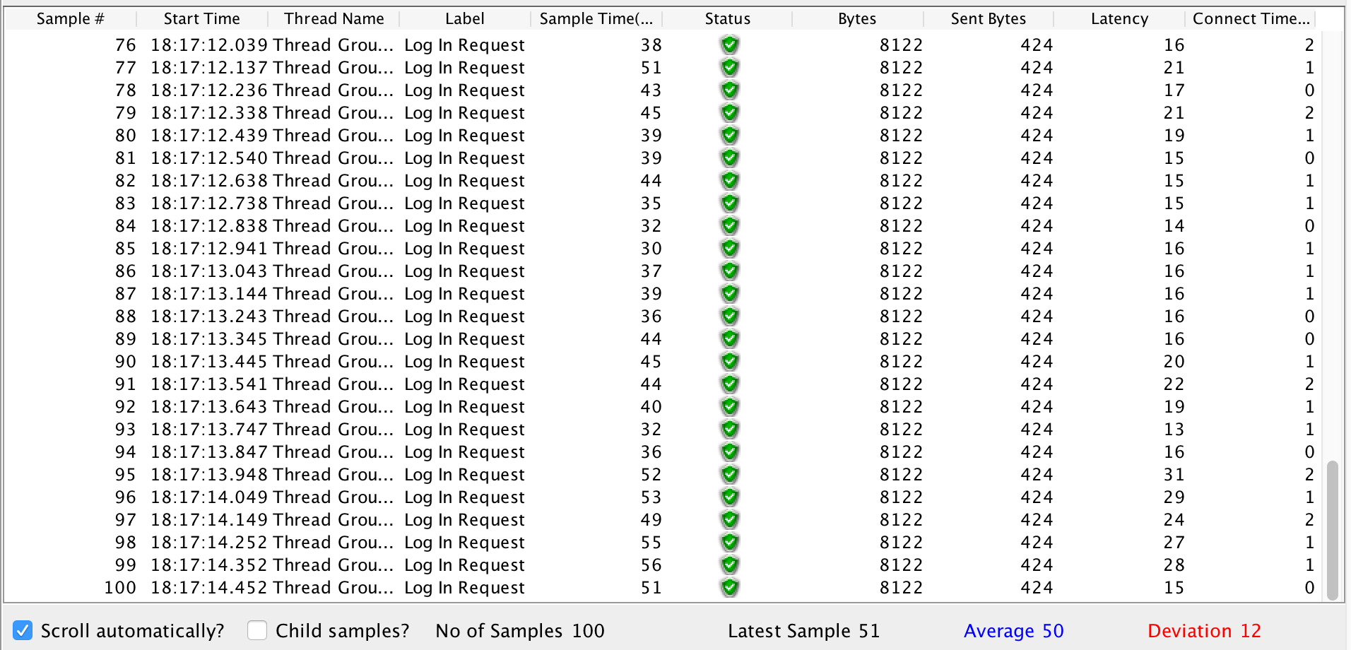

1000 users 10 Ramp-up Time

With 1000 users and 10 Ramp-Up time, the server failed to handle every request. Near ¼ of the requests where denied by the server and the average time for each request was 10737ms, which is more than what would be acceptable. That means that the server can’t handle 100 requests per second, over 10 seconds.

